Religious Education

Class 3 Week Beginning: 22nd February 2021

**Topic: Listening and Sharing**

The Eucharistic Prayer gives thanks for all God’s goodness. The greatest of all gifts is Jesus and in this prayer the Church remembers the special meal of the Last Supper. This is a time when the priest speaks the words of the prayer and the parish family listen carefully and pray quietly in their hearts. Holding the host, the priest says the words Jesus used at the Last Supper:

“*Take this, all of you and eat of it; for this is my Body, which will be given up for you.”*

(Jesus’ words mean ‘This is my living presence today, this is myself, this is me’.)

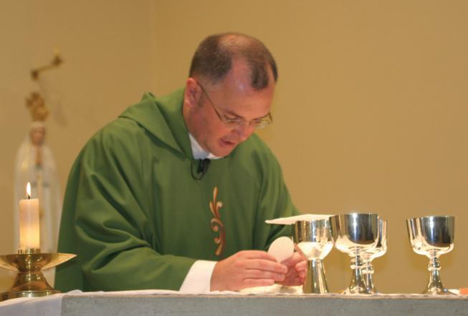

Holding the chalice, the priest says,

*“Take this, all of you and drink from it;   
For this is the chalice of my Blood,  
the Blood of the new and eternal covenant.   
which will be poured out for you and for many for the forgiveness of sins,  
Do this in memory of me.”*

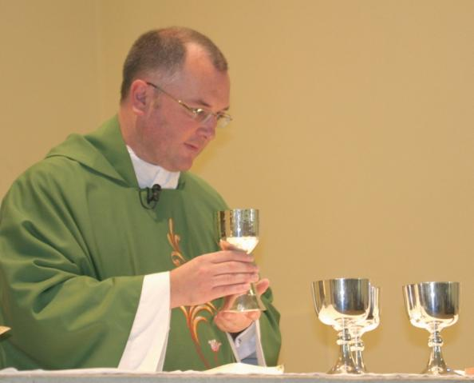

By the power of the Holy Spirit the bread and wine have now become the Body and Blood of Jesus. At the very end of the Eucharist Prayer everyone says ‘Amen!’, which is a Hebrew word. It means ‘let it be so’, ‘we agree’.  
[Bread and wine was part of the staple diet of people at the time of Jesus.  
New eternal covenant can be explained to children in this year group as Jesus being with us in the past, the present and in the future.]

**Task:**

Draw and label these significant points in the Mass using religious words. Write a sentence to describe what is happening and who is involved (what they are doing and why)

