Religious Education
Class 3 Teacher: Mrs Hanley Week Beginning: 8th February 2021
Topic: Listening and Sharing
Lesson 2: On Sunday, members of the parish family come together to share the Sacrament of the Eucharist. Welcomers greet the people as they come into the church and give them the books they need. The musicians get their music ready. The altar servers and the priest put on their vestments. When the time comes to begin Mass, someone rings a bell, and everyone stands up to sing the Gathering Hymn. The servers then come in followed by the priest. This is the beginning of the Introductory Rite. Rite means the action of God’s people, ceremony or act.
The priest and people make the Sign of the Cross as the priest says, “In the name of the Father and of the Son and of the Holy Spirit.” and the people respond, “Amen!” He welcomes the parish family using the words, “The Lord be with you.” Everyone replies, “And with your spirit.”
This reminds us of the ending of the second letter of Paul to Timothy, this is what he says:
‘The Lord be with your spirit. God’s grace be with you all.’ 2 Timothy 4: 22
- Why do members of the parish family come together on a Sunday?
- How do the people prepare for Mass?
- What happens during the gathering?
- What do you think Paul’s words to Timothy mean?
Lesson 3: During the Liturgy of the Word, the readings proclaim the message of God’s love and truth, mercy and forgiveness as it has been told by the People of God in the Old and New Testaments. On Sunday at Mass there are three readings.

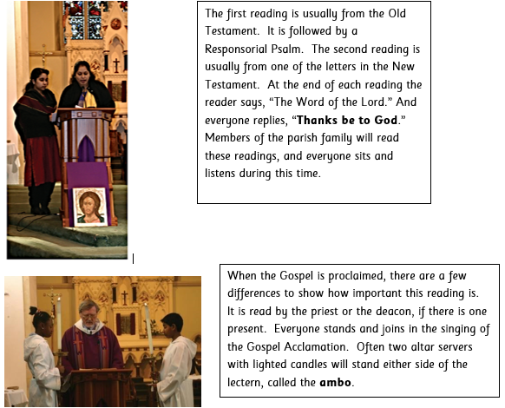

The priest or deacon makes the Sign of the Cross on the page of the Gospels, his forehead, lips and heart. The people also make the Sign of the Cross on their foreheads, lips and heart, in preparation to hear the Good News of the Gospel of Jesus Christ. We make the Sign of the Cross on our foreheads to show we believe in God’s Word, on our lips to show we try to speak God’s Word to others, and on our hearts to show we love God’s Word and will try to live a good life.
Christians believe that God speaks through the Scriptures and that the Gospel is the Good News. Watch an online Mass and listen and watch carefully as the Gospel is being read.
- What is the Liturgy of the Word?
- Why does God speak to us through the Scriptures?
- Why is it important to listen?
- Why do you think there is a difference in the way the Gospel is proclaimed and who reads it?
- What preparation do people make to hear the Gospel? What do you think this means?
- In what ways is the Gospel ‘Good News’ for the followers of Jesus?
Task:
We get ready to listen to the Gospel by singing Alleluia and by tracing a sign of the cross with our thumb three times, first on our forehead, then on our mouth, then over our heart:
on our forehead: as we ask that the Word of God may stay in our minds and our thoughts
on our mouth: as we ask that our words and actions may stay on our lips
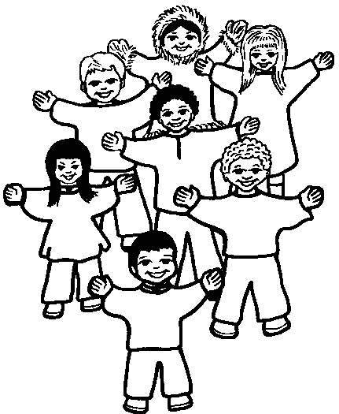
over our heart: as we ask that the Word of God may stay in our hearts
Draw these three stages of preparing for the Gospel (the 3 small crosses) and explain them – I have set this as a 2Do for you called ‘Preparing for the Gospel’

