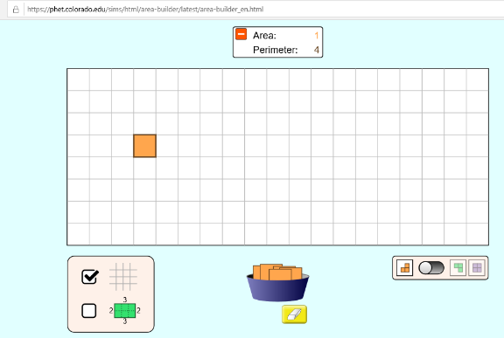
Investigating Area and Perimeter
Using this website https://phet.colorado.edu/sims/html/area-builder/latest/area-builder_en.html complete the table below to show what you found out. I have done the first one for you. You could even write it out into your books rather than type.

Number of squares used | Area cm sq | Perimeter cm
1
2
3
4
5
6
7
8
9
10
20
30
40
50
60
70
80
90
100

