MATHS Tues 09.02.21
Perimeter of rectilinear shapes
Work out the perimeter of each shape…
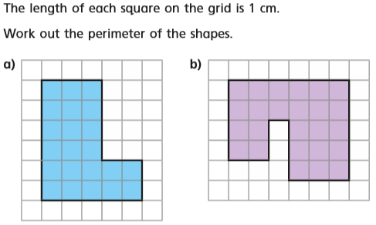
The perimeter of a is: The perimeter of b is:

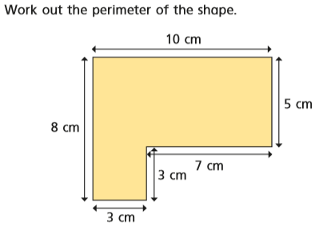
The perimeter is:

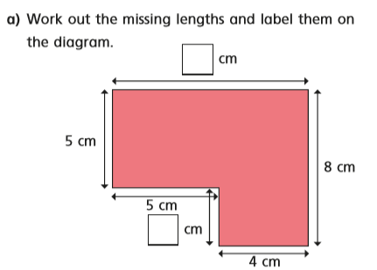
A
A

A =
B =

B
A

What is the perimeter of this shape?
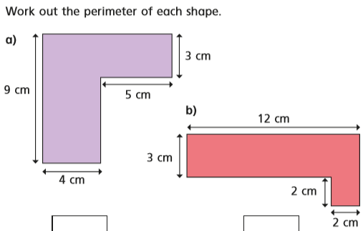

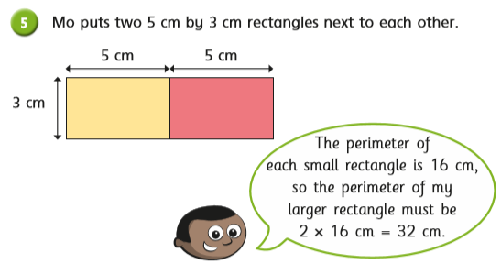
Is Mo correct?
Show your working out to check your answer.
Dani thinks there isn’t enough information to work out the perimeter of this shape.

Is Dani correct?
Explain your answer:

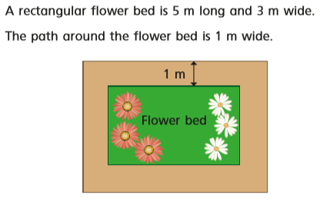

What is the perimeter of the flower bed?
What is the perimeter of the outside of the path?

