Work out the following…

Number of squares =
Area = square cm/ cm²
Perimeter = cm

Number of squares =
Area = square cm/ cm²
Perimeter = cm

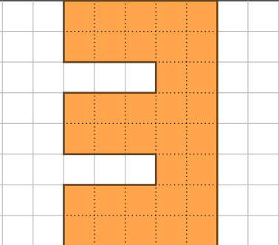
Number of squares =
Area = square cm/ cm²
Perimeter = cm

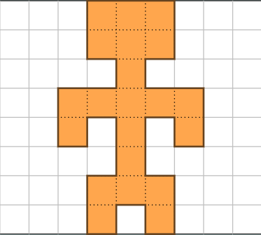

Number of squares =
Area = square cm/ cm²
Perimeter = cm

Complete this table showing the measurements of rectangles – don’t forget to include the units of measure cm and cm².
Length | Width | Perimeter | Area
2cm | 3cm
5cm | 4cm
6cm |  | 18cm | 18cm²
 | 7cm |  | 21cm²
20cm | 50cm | 140cm
12cm | 30cm
 | 4cm |  | 24cm²
50cm | 100cm
 |  | 34cm | 70cm²
 |  | 50cm | 24cm²
Use https://phet.colorado.edu/sims/html/area-builder/latest/area-builder_en.html to help you or to check your answers.

