MATHS Mon 08.02.21
Calculating Perimeter
Work out the perimeter of each shape…
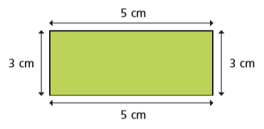
The perimeter in cm is: The perimeter in mm is:

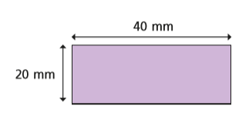

The perimeter in cm is: The perimeter in mm is:
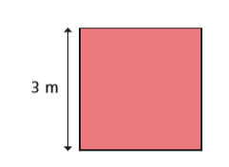
The perimeter in m is: The perimeter in cm is:

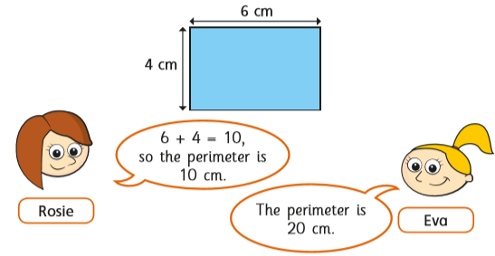

The girls try to work out the perimeter of this rectangle. Who is right Rosie or Eva?
Explain your answer here:

Which of these 4 shapes have a perimeter of 16cm?
A 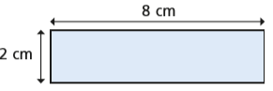B 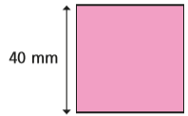 C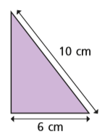D 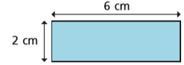
Type your answer here:
Look at these shapes….
A 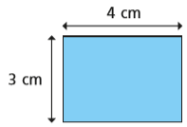 B 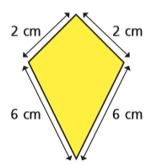 C 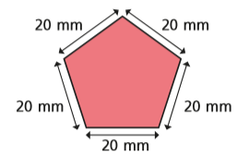
Which shape has the longest perimeter?

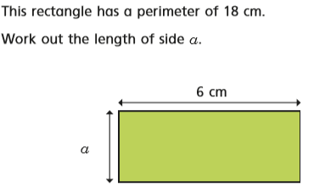
The length of side a=
Work out the perimeter for these shapes.
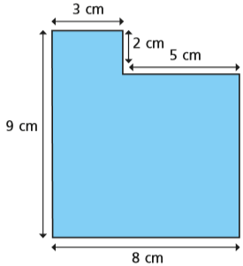
The perimeter of this shape is
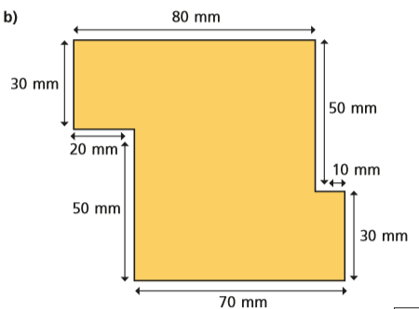
The perimeter of this shape is

