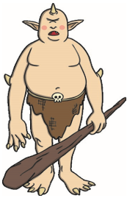
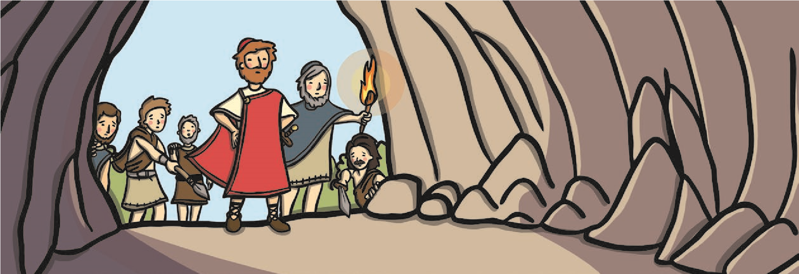
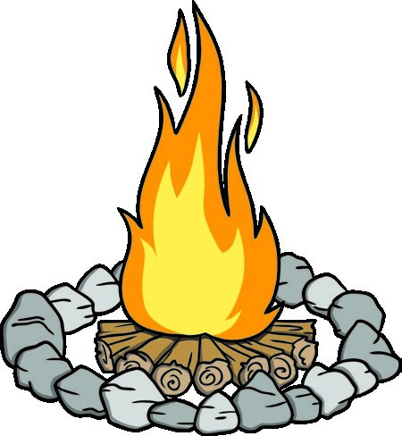
Odysseus and Cyclops
A long time ago, there was an island in the sea called Sicily. The sun shone every day on this island and it was beautiful and green, with lots of different plants and lush green grass. The sea that surrounded the island was blue and very clear.
On this island, there lived Cyclops, a one-eyed creature who was as big as a house, with enormous hands and feet and a glaring round eyeball in the middle of his forehead.
One day, a man called Odysseus, who was famous all over
the world for his quick mind and his cunning tricks, saw the island from his sailing boat. He decided that he would go ashore with a group of 12 brave men and see what was on the island.
When they got ashore, the men scrambled up the steep cliffs and explored the woods. They didn’t see anyone and the island seemed to be deserted. However, high up on the mountain, they discovered an enormous cave.
Inside the cave, they found sheep and goats living in pens, and on the ground, they found cheese and barrels full of milk. The men wanted to steal the food, but Odysseus was a good man and wanted to wait and ask the owner if they could take it. They lit a fire and settled down to eat and drink.
As the sun was setting, they heard someone arrive and the noise of sheep. A herd of sheep came into the cave, followed by a giant who had one eye in the middle of his forehead. The men and the giant were very surprised to see each other and the giant demanded to know, “Who are you?”
“We are Greeks and are on our way home from a war in Troy,” answered Odysseus. “We would like to take with us food and drink for our journey.”
Cyclops was very angry and shouted, “I do not care who you are! You will not take my things!” At that, he grabbed two of the men and pushed them into his mouth, eating them quickly. He then took a huge boulder and rolled it in front of the door of the cave, trapping Odysseus and the other men inside.
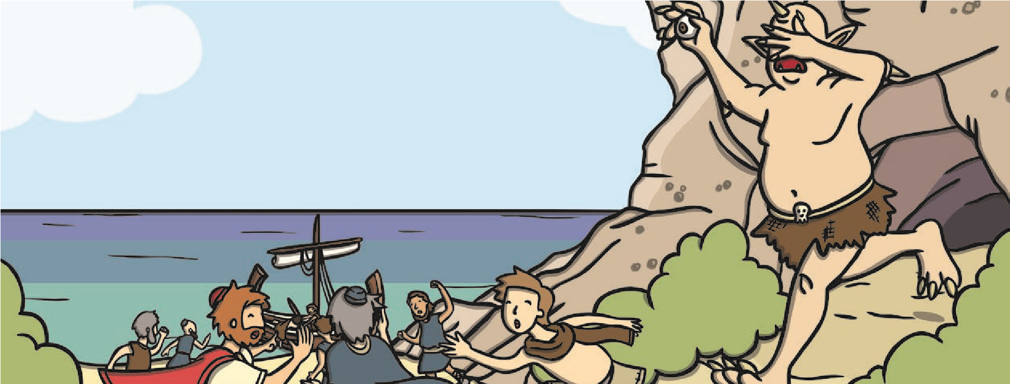
Odysseus was a wise man and he sat down to think about what could be done to escape, while the rest of the men slept through the night. As morning came, he knew what he had to do. Cyclops had left a huge stick in the cave and Odysseus ordered his men to sharpen the end of it so that it made a point. Then, they waited for Cyclops to come home.
When Cyclops arrived at the cave, Odysseus said to him, “Let us not be enemies, Cyclops my friend. Come and share my wine with me and let us talk.”
Cyclops had never tasted wine, but took a long drink and found that he really liked it. Odysseus and Cyclops chatted throughout the evening and, before he knew it, Cyclops had finished all of the wine and fell into a deep, deep sleep.
Odysseus saw his chance and ordered his men to plunge the sharpened stick into Cyclops’ eye. Cyclops screamed and shouted, “I am blind, I am blind!” and desperately tried to grab the men.
Odysseus told his men that the only way to escape Cyclops’ grasp was to tie themselves underneath the sheep, who were trying to escape from the cave in all the commotion. As each sheep went out, Cyclops stroked it to check that a man was not riding on its back. The last animal to leave the cave was the old ram with curly horns. Odysseus was clinging to its underside. Cyclops stroked the ram and said, “I have been blinded, but I shall have my revenge. I shall find those men tonight hiding in the corner of the cave, and I shall eat them all for dinner.”
Odysseus and his men were now out of Cyclops’ reach, so they untied themselves from the sheep and ran back to the beach. They got into their boat and were able to sail away to safety, leaving Cyclops alone on the island.
Comprehension Questions
Type your answers underneath the question.
- What was the name of the island?
- What did Cyclops look like?
- Why does the author use the simile ‘as big as a house’ to describe Cyclops?
- Who was Odysseus?
- What did Odysseus and his men do when they got onto the island?

- What was inside the cave?

- What did the men do when they were in the cave?

- How did Cyclops feel when he saw Odysseus and the men?

- What two things did Cyclops do when he saw the men?

- What did Odysseus ask the men to do with the stick?

- What happened to Cyclops when he had drunk the wine?
- How did the men escape from the cave?
- Did Cyclops get what he deserved? Explain your answer.

