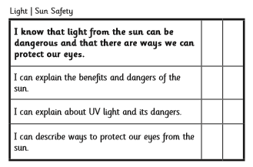
Sun Safety Design Task 2
After watching the PowerPoint your task is to design a poster to warn people about the dangers and need for protection from the sun. Use the Success grid here to help you know which information to include.

