Mirror Magic

Every object r________________ light, that’s why we can see them. But some reflect light in a more organised way than others. m_____________ (and other s_______ surfaces) reflect light in an organised way and that is why we see clear i____________ in them. Other surfaces which are r_____________ reflect light rays, but s________________ them rather than reflect in an organised way. That is why we can’t see an image in them.
scatter images smooth rough
mirrors reflects

Mirror writing

Below is an image of mirror writing, the writing is backwards, but if you put a mirror alongside it you can read it!
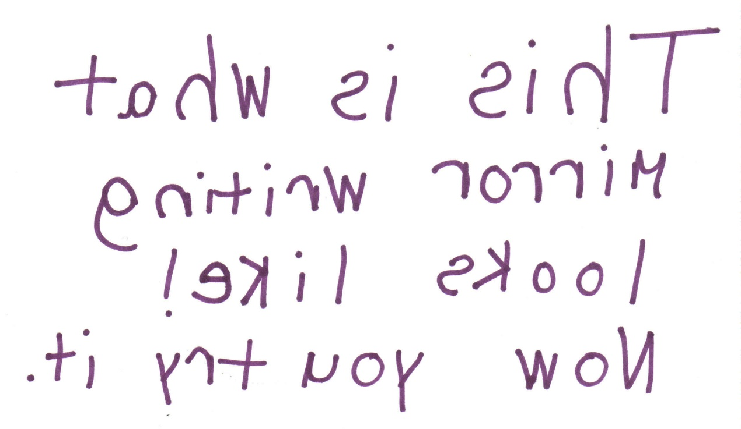
Now you have a go end each other a message – you could do this in 2Paint and send via Purple Mash!

