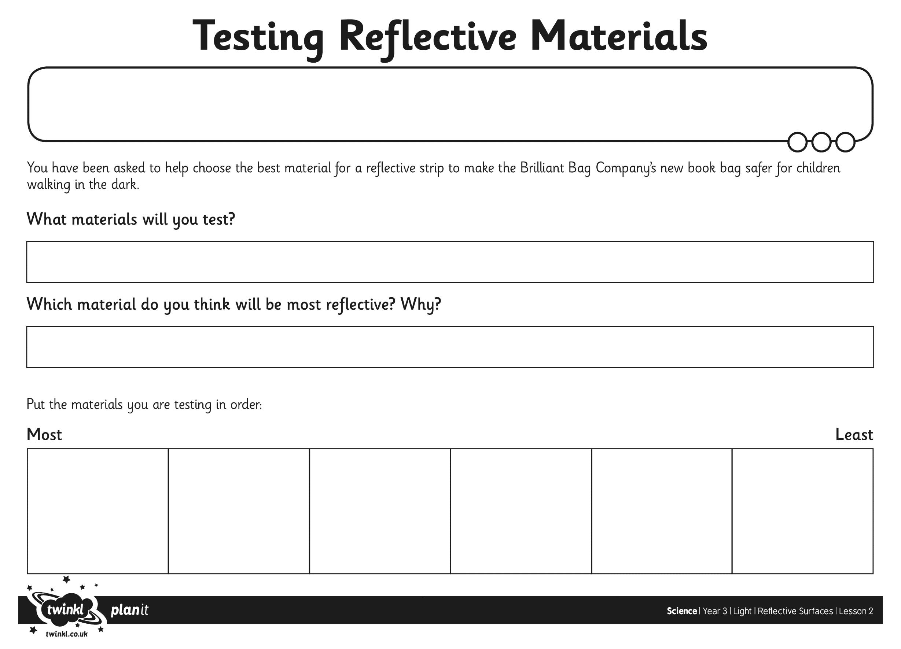

Type here

Type here

Type here

Type here

Type here

Type here

Type here to tell me what you are going to do

Type here your prediction

Type here the materials you have found to use