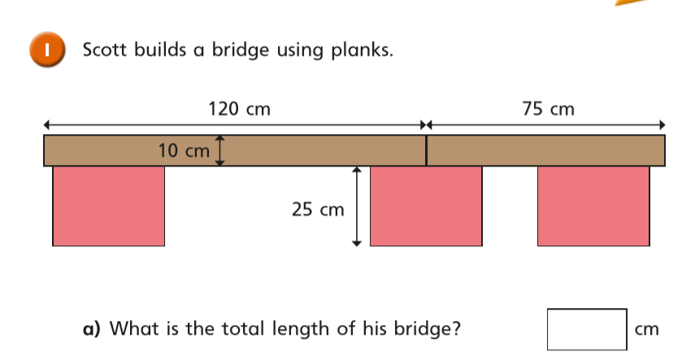

?



?

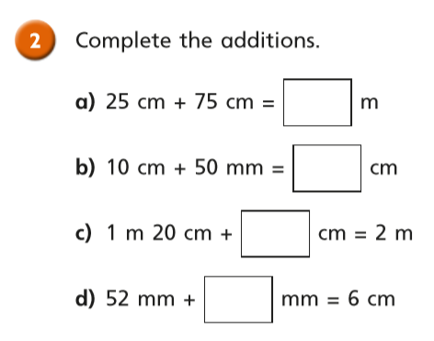

?

?

?

?

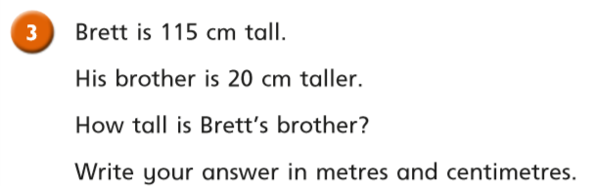

?

?

m and cm

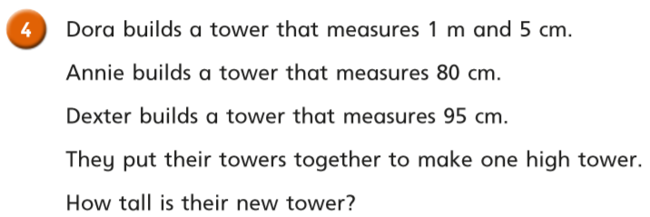

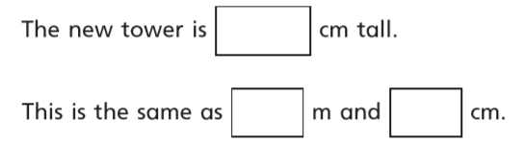

?

?

?

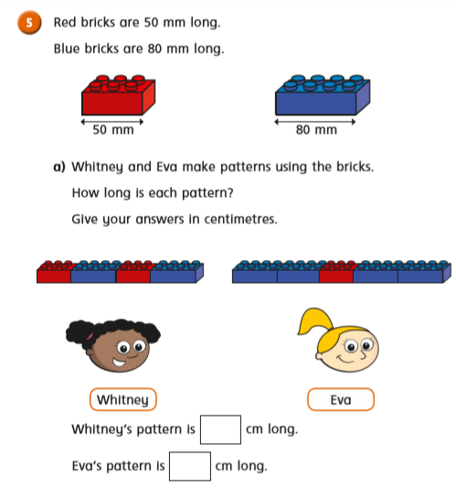

?

?

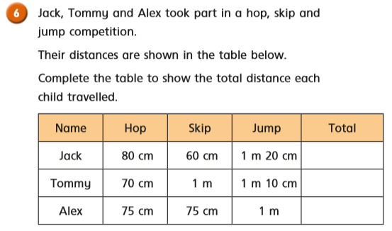

?

?

?

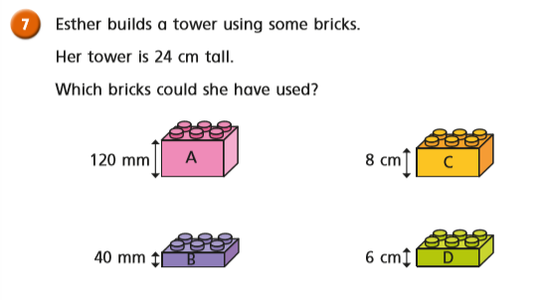

Record your answers below like this:  
   
 Tower 1: A + A = 24cm

Tower 2:

Tower 3:

Tower 4:

Tower 5: