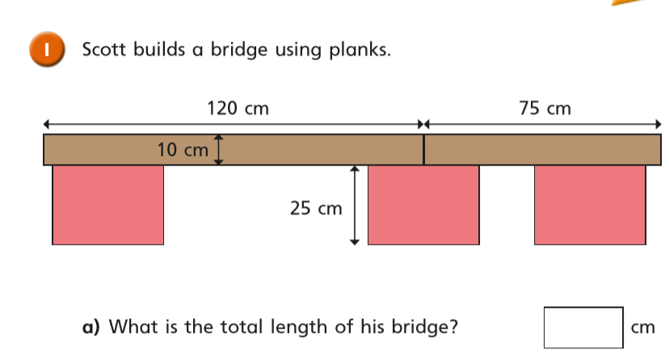

7cm

12cm

?



?

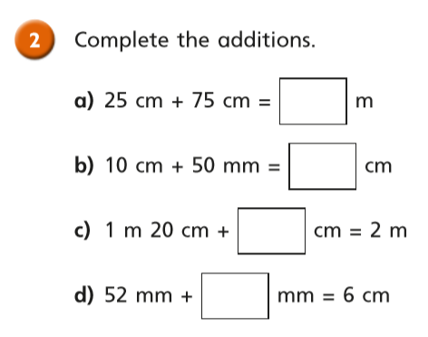

?

?

?

?

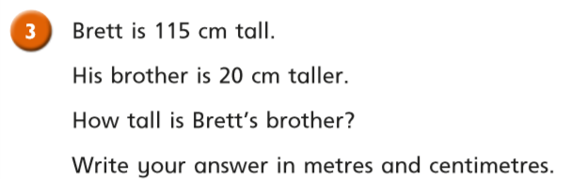

?

?

m and cm

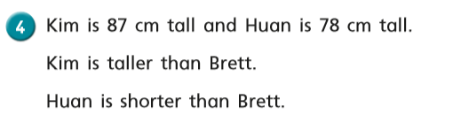

Highlight below the heights that Brett could be

|  |  |
| --- | --- |
| 80cm | 87cm |
| 78cm | 86cm |

?

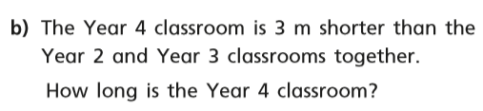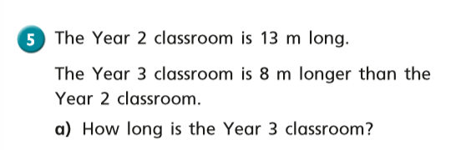

? m

?

? m







