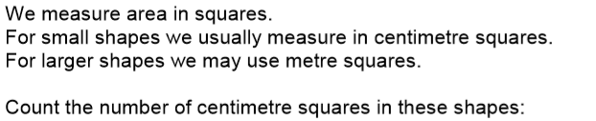
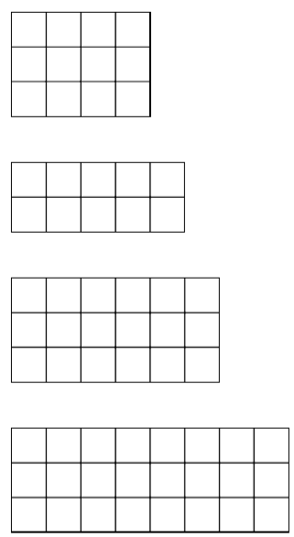

Number of squares =
Area = square cm
= cm²

Number of squares =
Area = square cm
= cm²

Number of squares =
Area = square cm
= cm²

Number of squares =
Area = square cm
= cm²

