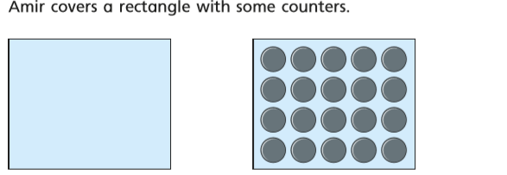

- Amir thinks the area of the rectangle is exactly 20 counters.
Is Amir correct? Type your answer here
- Explain below why counters are not the best way to measure area.
.

Tick which shape
Tick which shape
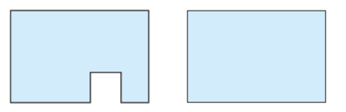
Which shape has the largest area?
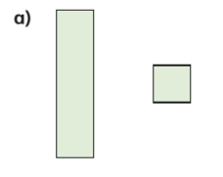

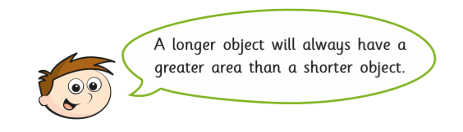

Do you agree with Teddy? Type your reasons below.

