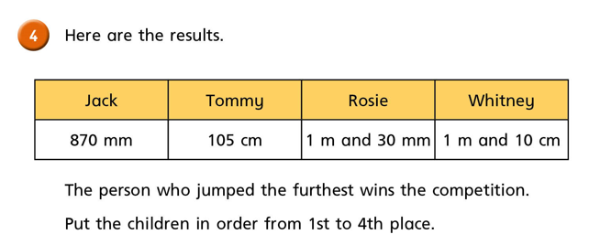

1st | 2nd | 3rd | 4th
Type here

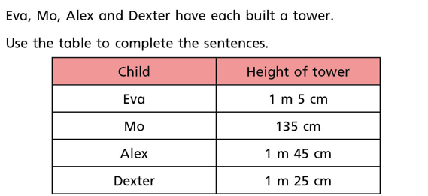
Look at the table and answer these questions:
- Type here‘s tower is the tallest.
- ‘s tower is the shortest.
- Mo’s tower is than Dexter’s.
- Eva’s tower is than Alex’s.

Write the following lengths in longest to shortest:
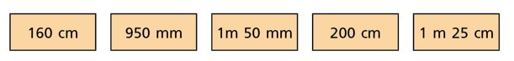
Longest Shortest

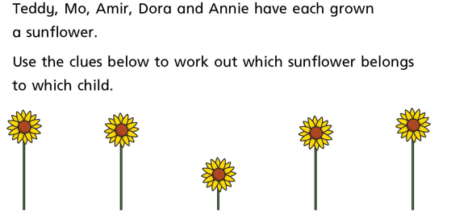
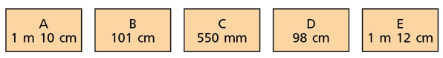
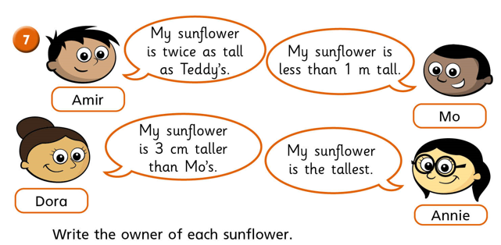
Sunflower A: type here Sunflower B: Sunflower C: .
Sunflower D: Sunflower E: .

