- Highlight the letter of the shape with the largest area.
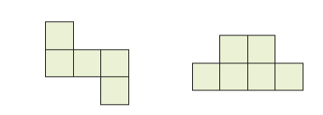
A or B
- Highlight the letter of the shape with the smallest area.
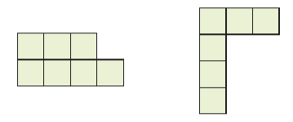
A or B

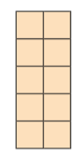
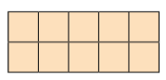
- 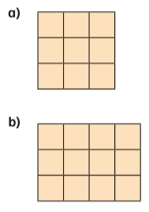
?
?

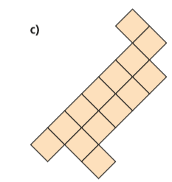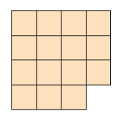
?
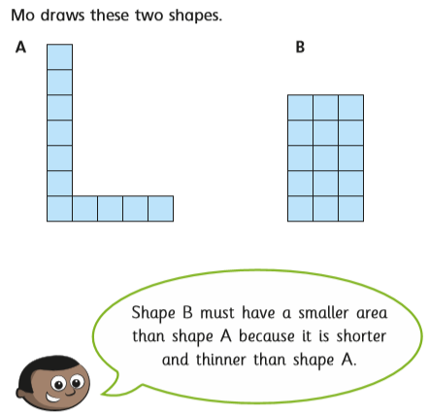
Do you agree with Mo? Yes or No
Explain your answer:

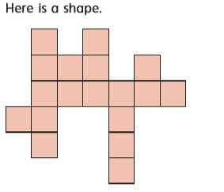
What is the area of the shape?
squares

Use this grid to highlight a shape with an area which is 2 squares larger than the answer to the last question. Use the fill tool from the tool bar – it looks like a tin of paint that is spilling!

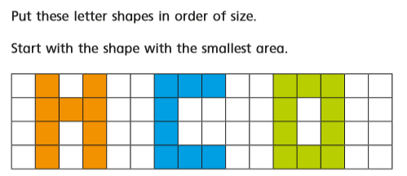

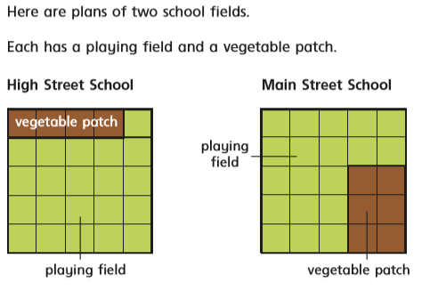

- What is the difference in the area of the playing fields?
The difference in the area of the playing fields is squares.
What is the difference in the area of the vegetable patches?
The difference in the area of the vegetable patches is squares.

