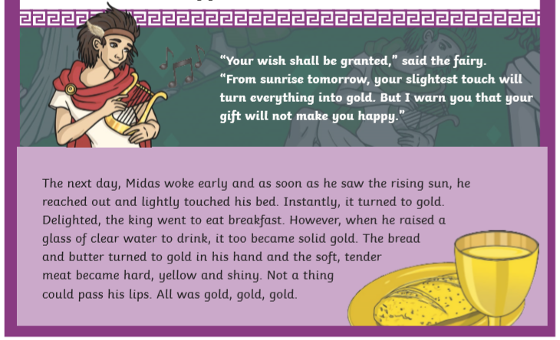
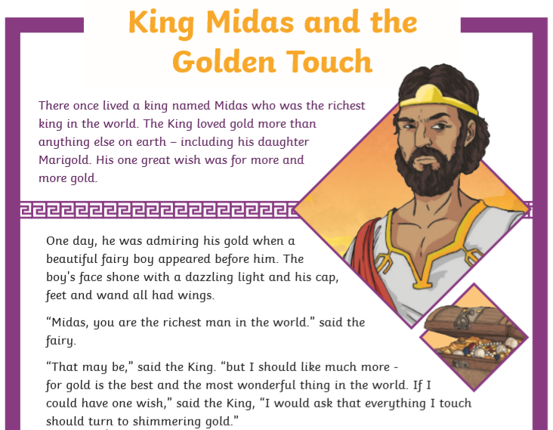

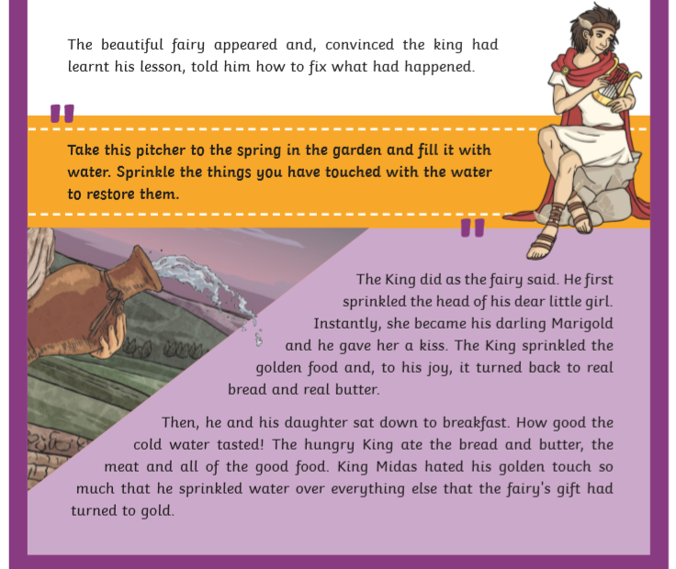
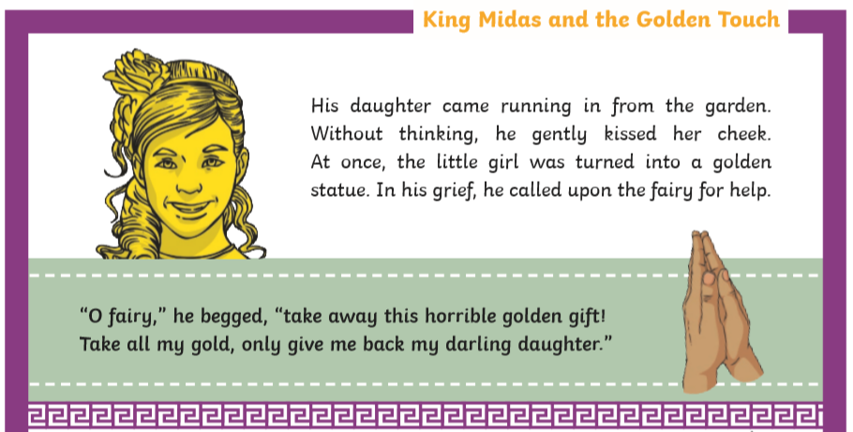

Questions – Remember to answer in FULL sentences!

crying
admiring his gold
eating breakfast
shouting
- What was Midas doing the first time the fairy appeared? (shade the box)
- How did the Fairy warn Midas about his gift?
.
King Midas | powerful
Marigold | innocent
The Fairy | greedy
- Match the character to the adjective that best describes them. (Shade the boxes to match in colour).
- Fill in the missing words.
The next day, Midas early and as soon as he saw the sun, he reached out and lightly touched his bed.
- Read the sentences below. Highlight the sentences which are true - turquoise and those that are false - fuchsia.
The gift would work from sunset the next day.
King Midas changed his daughter back first.
The first thing Midas changed to gold was some bread.
The fairy told Midas how to change everything back.
- Explain how Midas turned Marigold into a statue.
.
- Imagine you are the fairy, would you have granted Midas’ wish? Give reasons for your answer.
.
- When do you think King Midas’ attitude to gold changed in the story? Use evidence from the text to support your answer.
.
- What do you think the moral (message) of the story is?
.

