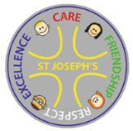
Day
Monday | This morning I’d like you to explore the Class Notebook section and the Collaboration Space in particular. This feature is where we can write collaboratively. So, your first task is to find the section down the side that says Class Register – open the class register for  Mon 25th Jan read your instructions and complete the task (see below for help).  Also check your daily Assignments for today Reading Comprehension. | I will be available to feedback, answer questions and offer support between 1.30-2.30pm
Tuesday | Today I would like to continue to develop your collaborative writing skills and link in with your work last week on eSafety.  I want you to contribute to our Class 3 Teams Charter. Find the section down the left-hand side in the Collaboration Space, then read the task.  Also check your daily Assignments. | I will be available to feedback, answer questions and offer support between 1.30-2.30pm
Wednesday | Today you can see me explain today’s English task.  The Powerpoint explains what I want you to do this is in your Assignments.  You also have Maths task – please see your Maths planning for this week. | I will be available to feedback, answer questions and offer support between 1.30-2.30pm
Thursday | Today you have all of your Assignments to work through: Maths, SPaG and English.  But today we have a new skill to master!  At 2.45-3pm we will try to go ‘Live’ (I will explain how to join in our General chat thread) so we can see each other to say hello and have a little catch up. | I will be available to feedback, answer questions and offer support between 1.30-2.30pm
Friday | Today in Assignments you will find a Spelling Quiz with I would like you to complete. It’s multiple choice using Microsoft Forms – so I want you to practise using this feature of Teams for future Assignments. Good Luck! | Join live at 10.30 for a live spelling test  I will be available to feedback, answer questions and offer support between 1.30-2.30pm
Class 3 Microsoft Teams Timetable
Week beginning 25.01.2021

Please note that questions may be asked via Teams at anytime but as we are also working with some children who are accessing key worker/ vulnerable provision in school, we may not be able to get back to you immediately. We will do our best to get back to you a.s.a.p. Thank you for your patience and understanding.
Stay Safe and keep doing what you’re doing!

Where to find this week’s Collaborative Space…
Click ‘Class Notebook’ then hiding down the side you’ll see two icons a magnifying glass and three ‘books’ on their side.
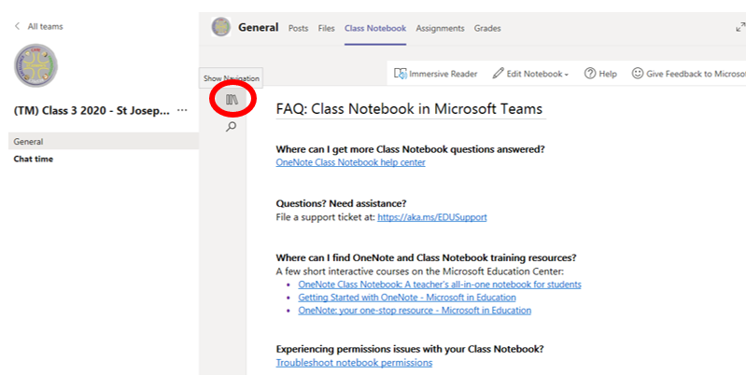
Then click these ‘books’ and click the Collaboration Space….
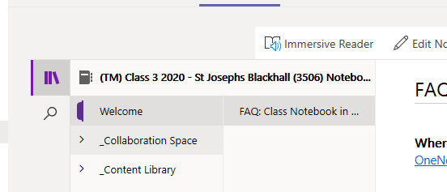
This opens the tasks mentioned on your Timetable. You already know where to find Assignments.
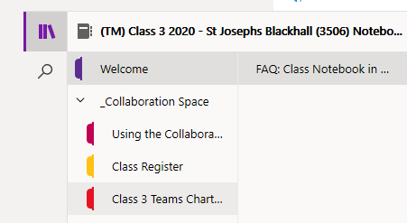

Any problems – let me know

