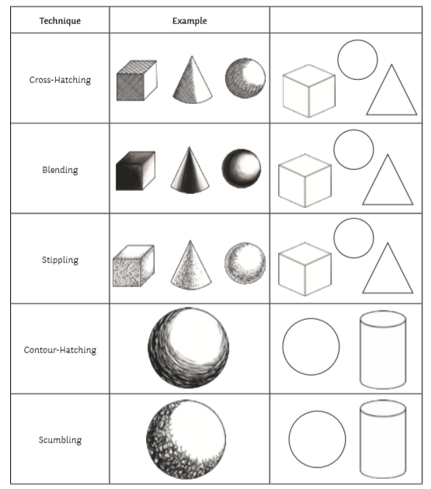
ART Session 2 – Your task is to try these techniques, draw 1 or 2 of these shapes and have a go yourself.
Send me pictures via Teams

