Monday 20th April 2020
- Can you find some powerful verbs in the text? Make a list of your favourite ones.
Remember!
Powerful verbs are verbs that are exciting and descriptive, e.g. instead of using ‘said’ use ‘shouted’ or ‘screamed’.

- How would you describe the main characters? Are they kind or cruel? How do you feel about them?
- How do you think it must feel to be able to fly? What did you think about the story? How does it make you feel?
Tuesday 21st April 2020
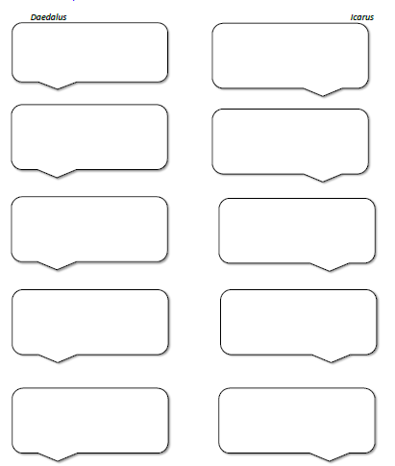
Use the speech bubbles to write down a conversation between Icarus and Daedalus before they set off.

Wednesday 22nd April 2020
Using your speech bubbles and what you have learnt about punctuating direct speech write out your conversation between Daedalus and Icarus. Think carefully about how they might say each sentence.
You can handwrite or type it here.

